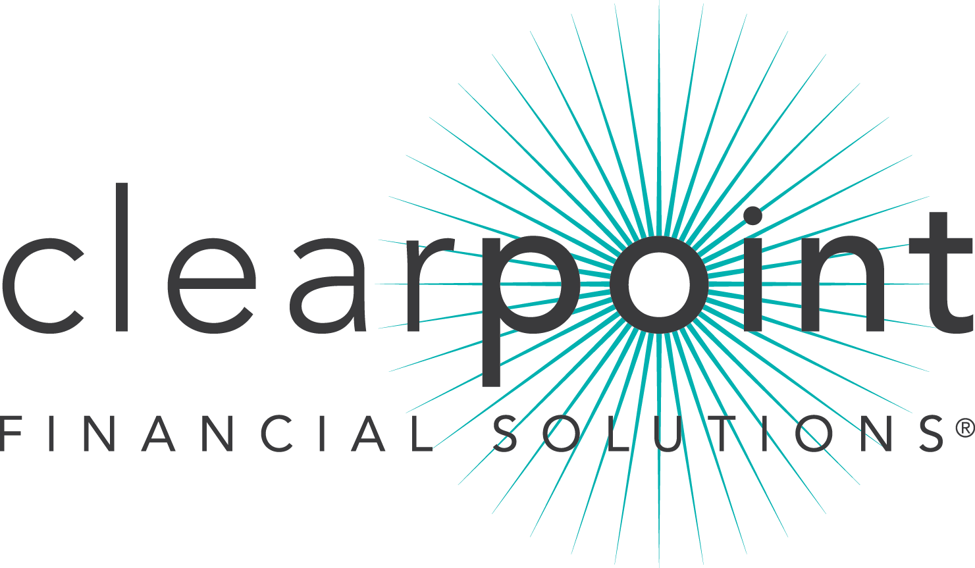

FOR IMMEDIATE RELEASE CONTACT: Anay Villlar|305-586-3298
August 8, 2014 Anay.Villar@ClearPointCCS.org
Thomas Nitzsche |404-490-2227
Thomas.Nitzsche@ClearPointCCS.org

MEDIA ADVISORY

ClearPoint Financial Solutions celebrates the grand opening of the Hispanic Center for Financial Excellence (HCFE) uniquely dedicated to serve the Miami Hispanic community to achieve long-term financial security through year-long free advising programs.

WHAT: The Grand opening and ribbon cutting ceremony of ClearPoint’s Hispanic Center for Excellence.
ClearPoint, the second largest national nonprofit credit counseling agency in the nation, is expanding its service with the creation of the second Hispanic Center for Financial Excellence in the country and the first of its kind in Miami. The center offers customized financial advising programs especially designed for local Hispanics to empower them to attain long-term financial security at different moments of their lives over a year-long program.

An experienced team of ClearPoint’s HCFE bilingual financial advisors meet with clients to discuss their needs, assess their current situation, and establish a personalized action plan. In addition, financial educators reach out to the community offering workshops covering the most relevant financial topics impacting the Hispanic community.

Services are offered free of charge and are provided face-to-face and via telephone in English and Spanish.

WHO: ClearPoint Financial Solutions and its team of financial experts

WHEN: Thursday, August 28, 2014, 11 a.m. to 1 p.m.
Ribbon Cutting Ceremony at 12 p.m.

WHERE: 7200 Corporate Center Drive, Suite 200 Miami, FL 33126
Event will be held at the main lobby.

ClearPoint is a member of the National Foundation for Credit Counseling (NFCC), a system-wide accredited business with the Council on Better Business Bureaus, and a Housing and Urban Development (HUD)-approved housing counseling agency. Free appointments at the HCFE may be scheduled by calling 305.592.9298. For more information about ClearPoint, visit www.ClearPointCCS.org.

###

