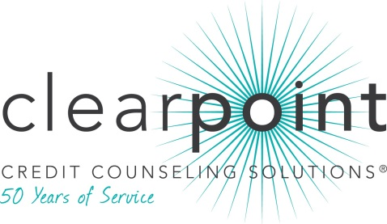
FOR MORE INFORMATION:
Thomas Nitzsche | 877-877-1995 ext. 2675 | thomas.nitzsche@ClearPointCCS.org
1-877-877-1995 | www.ClearPointCCS.org

BBB’s Randy Hutchinson honored by ClearPoint Credit Counseling Solutions (CCCS)

Memphis, TN (December 31, 2013)– Randy Hutchinson, President and CEO of Better Business Bureau of the Mid-South, has been presented with the national 2013 Howle Community Support Award by ClearPoint Credit Counseling Solutions (CCCS).

Mr. Hutchinson is an active member of ClearPoint’s Regional Advisory Committee in Memphis, providing education to the committee on scams and other consumer issues. He has been a tireless supporter and vocal ambassador for ClearPoint in the community and has introduced and recommended ClearPoint as a reliable source of valuable financial information to local businesses and media outlets, resulting in interview opportunities on WREG-TV and KWAM990 radio. Mr. Hutchinson has also facilitated partnerships with ClearPoint for various initiatives such as Secure Your ID Day shred events.

“Financially healthy consumers contribute to financially healthy communities,” said ClearPoint CEO Chris Honenberger. “Through his strong support of ClearPoint, Randy has served the people of Memphis by ensuring they have access to valuable financial education.”

For the third year, the Howle Community Support Award honors a ClearPoint Regional Advisory Committee member for advancing the nonprofit agency’s mission of consumer health through financial education. The national award’s namesake, Paul W. Howle III, is an innovator in the field of nonprofit credit counseling and served on ClearPoint’s Board of Directors for more than three decades.

Founded in 1964, ClearPoint is a member of the National Foundation for Credit Counseling (NFCC), a system-wide accredited business with the Council on Better Business Bureaus, and a Housing and Urban Development (HUD)-approved housing counseling agency. Free appointments for credit, debt, budgeting and most housing related issues may be made by calling 877.877.1995. For more about ClearPoint, visit www.ClearPointCCS.org. While you are there, be sure to check out the Know Your Money Blog.

###

