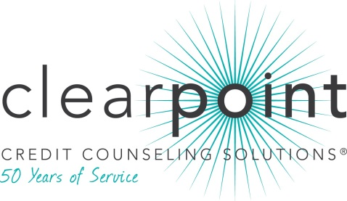
FOR MORE INFORMATION:
Thomas Nitzsche | 877-877-1995 ext. 2675 | thomas.nitzsche@ClearPointCCS.org
1-877-877-1995 | www.ClearPointCCS.org

Seattle’s Herb Weisbaum honored by ClearPoint Credit Counseling Solutions (CCCS)

Seattle, WA (December 31, 2013)– Herb Weisbaum, leading consumer expert and reporter, has been presented with the 2013 Petzall Community Service Award by ClearPoint Credit Counseling Solutions (CCCS).

Since 2009, Weisbaum has featured ClearPoint as a trusted resource for credit and housing counseling, starting with a KOMO-TV report that highlighted the dangers of deceptive debt settlement advertising, and continuing through 2013 with a CNBC report on student loan counseling and a Today Show story about debt settlement and taxes. Weisbaum also featured ClearPoint as a regular sponsor of his “Consumer Notebook” segment during 2011 and 2012 on KOMO radio. Weisbaum frequently advises his TV and radio audiences that ClearPoint is one of the “good ones,” and a trusted source for consumer education. This message, combined with his reputation of trustworthiness and reliability, has helped ClearPoint gain recognition as a dependable consumer resource.

“Herb is one of the most recognizable sources of trustworthy money advice in Washington state and beyond,” said ClearPoint CEO Chris Honenberger. “He has helped thousands of people through his tireless financial education advocacy.”

For the third year, the Petzall Community Service Award honors an individual who advocates independently for ClearPoint’s mission of consumer health through financial education. The award’s namesake, Gerhard J. Petzall, has been a distinguished member of the legal profession and a military veteran. Mr. Petzall has also served on ClearPoint’ Board of Directors for more than three decades.

Founded in 1964, ClearPoint is a member of the National Foundation for Credit Counseling (NFCC), a system-wide accredited business with the Council on Better Business Bureaus, and a Housing and Urban Development (HUD)-approved housing counseling agency. Free appointments for credit, debt, budgeting and most housing related issues may be made by calling 877.877.1995. For more about ClearPoint, visit www.ClearPointCCS.org. While you are there, be sure to check out the Know Your Money Blog.

###

